Cloud Computing Advantages :

1. Employ a myriad of related strategies ;
   1. High availability / Downtime, depending on SLA that you choose.
   2. Scalability, Vertically means capacity can be increasing by adding RAM/CPUs to a virtual machine or Horizontally means capacity can be increasing by adding instances of a resources (ie. VM)
   3. Elasticity, applications always have the resources they need.
   4. Agility, can be deployed and configured quickly as your apps requirements change.
   5. Geo distribution, data can be deployed to regional data centers around the globe, so the customers always have the best performance in their region.
   6. Disaster Recovery, the confidence that comes from knowing that your data is safe if disaster should occur.
2. Cloud computing is a consumption-based model, means end users only pay the resources that they use. ‘Whatever they use is what they pay for’. No upfront costs, no need to purchase and manage costly infrastructure that might not use to its fullest, Pay for additional resources when they are needed, and also the ability to stop paying for resources that are no longer needed.
3. Two different expenses that you should consider :
   1. Capital Expenditure (CapEx), upfront spending of money on physical infrastructure, and then deducting that upfront expense over time. The upfront cost from CapEx has a value that reduces over time.
   2. Operational Expenditure (OpEx), where you spend money on products or services and are build for them at the moment of use. These like day-to-day expenses that are paid for immediately. Opex is consumption-based model.

Cloud services on the other hand, are categorized as an Opex, because of their consumption model. There’s no asset for company. As a results, Opex has a direct impact on net profit, taxable income and the associated expenses on the balance sheet.

What are cloud Service models (different level of shared responsibility that a cloud provider and cloud tenant are responsible for) :

1. Infrastructure as a Service (IaaS): Most flexible category of cloud services, It aims to give you complete control

over the hardware that runs your application instead of buying hardware with IaaS you rent it.

* IaaS : Data Center, Networking Firewall, Servers and Storage.

1. Platform as a Service (PaaS) : Provide the same benefits & considerations as IaaS,but are some additional benefits

* PaaS : IaaS + Operating Systems, Development tools (Networking resources and VM)

1. Software as a Service (SaaS) : Software that centrally hosted and managed for you on your users or customers.

* SaaS : PaaS + Hosted applications.

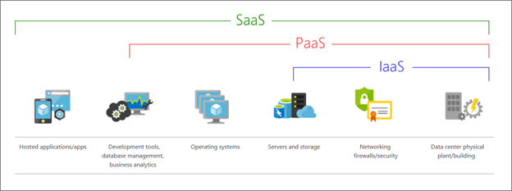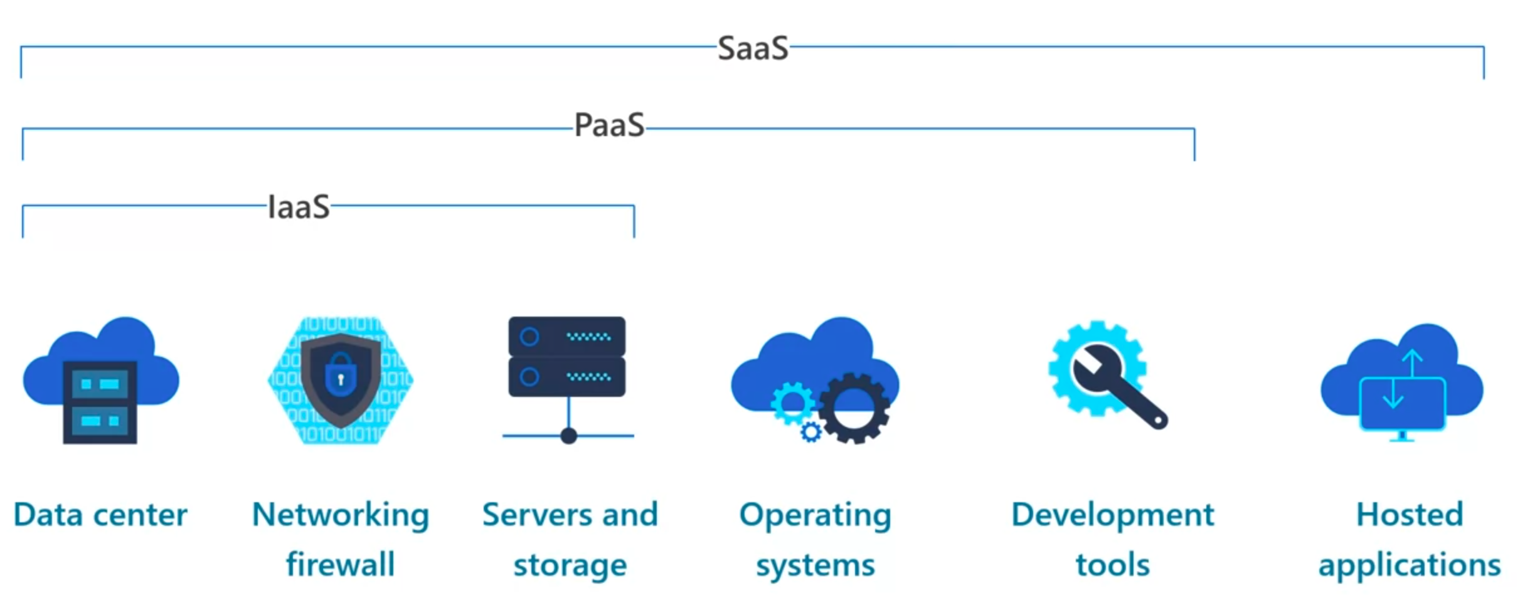

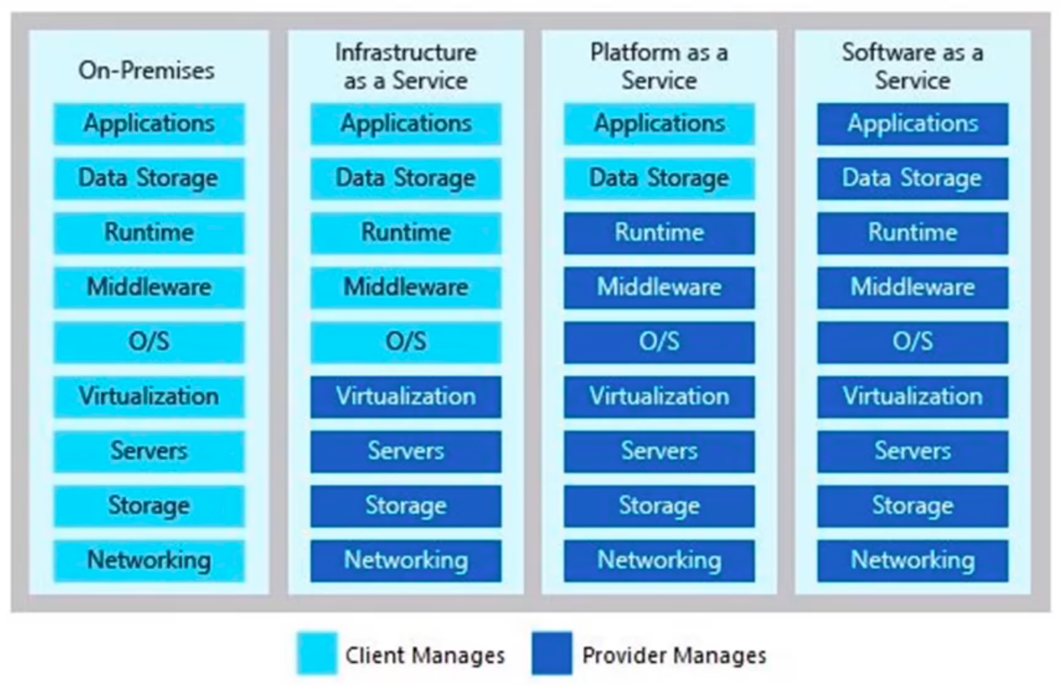

1. IaaS (*Infrastructure-as-a-Service)*

**Advantages:**

* **No CapEx**. Users have no up-front costs.
* **Agility**. Applications can be made accessible quickly and deprovisioned whenever needed.
* **Management**. The shared responsibility model applies; the user manages and maintains the services they have provisioned, and the cloud provider manages and maintains the cloud infrastructure.
* **Consumption-based model**. Organizations pay only for what they use and operate under an Operational Expenditure (OpEx) model.
* **Skills**. No deep technical skills are required to deploy, use, and gain the benefits of a public cloud. Organizations can use the skills and expertise of the cloud provider to ensure workloads are secure, safe, and highly available.
* **Cloud benefits**. Organizations can use the skills and expertise of the cloud provider to ensure workloads are made secure and highly available.
* **Flexibility**. IaaS is the most flexible cloud service because you have control to configure and manage the hardware running your application.

1. PaaS (*Platform-as-a-Service*)

**Advantages:**

* **No CapEx**. Users have no up-front costs.
* **Agility**. PaaS is more agile than IaaS, and users don't need to configure servers for running applications.
* **Consumption-based model**. Users pay only for what they use, and operate under an OpEx model.
* **Skills**. No deep technical skills are required to deploy, use, and gain the benefits of PaaS.
* **Cloud benefits**. Users can take advantage of the skills and expertise of the cloud provider to ensure that their workloads are made secure and highly available. In addition, users can gain access to more cutting-edge development tools. They can then apply these tools across an application's lifecycle.
* **Productivity**. Users can focus on application development only, because the cloud provider handles all platform management. Working with distributed teams as services is easier because the platform is accessed over the internet. You can make the platform available globally more easily.
* **Disadvantage**
* **Platform limitations**. There can be some limitations to a cloud platform that might affect how an application runs. When you're evaluating which PaaS platform is best suited for a workload, be sure to consider any limitations in this area.

1. SaaS (*Software-as-a-Service*)

**Advantages:**

* **No CapEx**. Users have no up-front costs.
* **Agility**. Users can provide staff with access to the latest software quickly and easily.
* **Pay-as-you-go pricing model**. Users pay for the software they use on a subscription model, typically monthly or yearly, regardless of how much they use the software.
* **Skills**. No deep technical skills are required to deploy, use, and gain the benefits of SaaS.
* **Flexibility**. Users can access the same application data from anywhere.
* **Disadvantage**
* **Software limitations**. There can be some limitations to a software application that might affect how users work. Because you're using as-is software, you don't have direct control of features. When you're evaluating which SaaS platform is best suited for a workload, be sure to consider any business needs and software limitations.

Like PaaS, **Serverless Computing** enables developers to build applications faster by eliminating the need for them to manage infrstructure. With serverless applications, cloud service providers automatically provisions scales, and manages the infrastructure required to run the code. Serverless architecture are highly scalable and event-driven, only using resources when a specific function or trigger occurs. Servers are still running the code, but serverless name comes from the fact that the tasks associated with infrastructure provisioning and management are invisible to the developer.

There are 3 (three) deployment models for cloud computing :

1. Public cloud, services are offered over the public internet and available to anyone who wants to purchase them. Cloud resources such as servers and storage are owned and operated by third-party cloud service provider and delivered over the internet.
2. Private cloud, consist of computing resources used exclusively by users from one business or organization. A private cloud can be physically located at your organizations onsite or on-premises data center. It can also hosted by third-party service provider.
3. Hybrid cloud , combine a public cloud and private cloud by allowing data and applications to be shared between them.

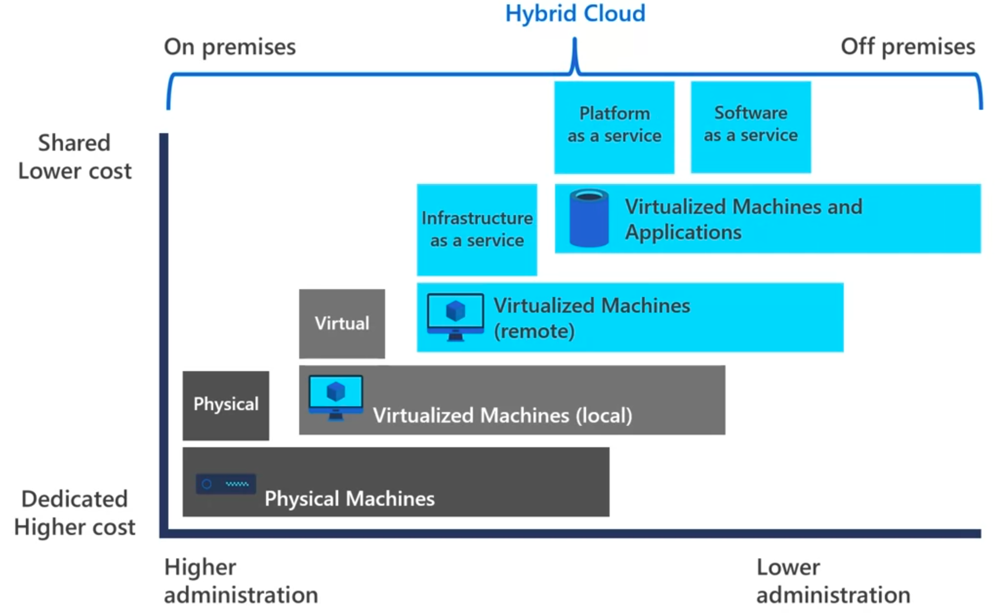 As your resources moved from on-premises to off-premises, your cost are reduced and your administrations requirements decrease.

Reading :

1. <https://azure.microsoft.com/en-us/resources/cloud-computing-dictionary/what-is-cloud-computing/>
2. <https://azure.microsoft.com/en-us/resources/cloud-computing-dictionary/what-are-private-public-hybrid-clouds/>
3. https://learn.microsoft.com/en-us/training/paths/microsoft-azure-fundamentals-describe-cloud-concepts/

Azure Subscriptions overview :

1. **Resources,** instances of services that you are create like VM, Storage and SQL database. Ie. VMs, Databases.
2. **Resource groups**, resources are combined into resource groups which act as a logical container into which Azure resources like web apps, databases and storage accounts are deployed and managed.
3. **Subscriptions**, a subscription groups together user accounts and the resources that had been created by those user accounts. For each subscriptions, there are limits or quotas on the amount of resources that you can create and use. Organization can use subscriptions to manage costs and the resources that are created by users, teams or projects.
4. **Management groups**, These groups help you manage access, policy and compliance for multiple subscriptions. All subscriptions in a management group automatically inherit the conditions applied to the management group.

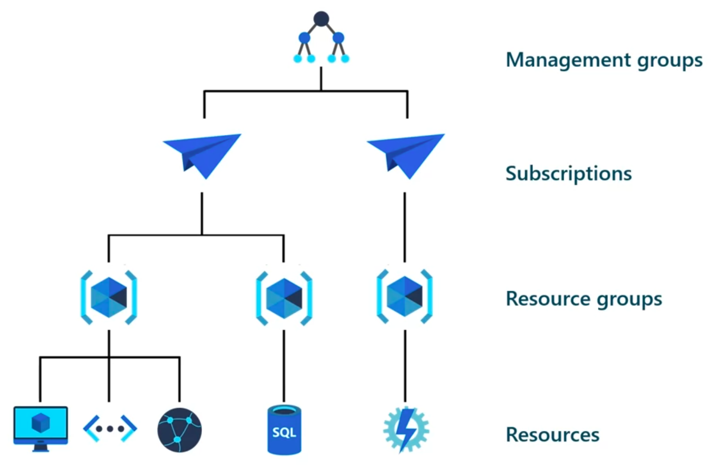

Start with Azure, means create at least one Azure subscription, to create cloud-based resources in Azure. Azure resources is a manageable item that’s available through Azure. VMs, Storage Accounts, web apps, Databases and Virtual Networks are all examples of resources. **Using Azure requires an Azure subscription.** A subscription provides you with authenticated and authorized access to Azure products and services. It also allows you to provision resources. Azure subscription is a logical unit of Azure services that links to an Azure account, which is an identity in Azure Active Directory, also called Azure AD, or in a directory that Azure AD trusts.

There are 2 (two) subscription boundaries that you can use :

1. **Billing boundary**, determines how an Azure account is build for using Azure. Azure generates separate billing reports and invoices for each subscription so that you can organize and manage costs.
2. **Access control boundary**, applies access management policies at the subscription level. You can create separate subscriptions to reflect different organizational structures.

* ie. **Organizational structures** for Multiple departments in a company distinct Azure subscription policies.
* ie. Subscriptions to **separate environments** for development and testing security, or to isolate data for compliance reasons.
* ie. **Billing subscriptions** for billing purposes to manage and track costs based on you needs.

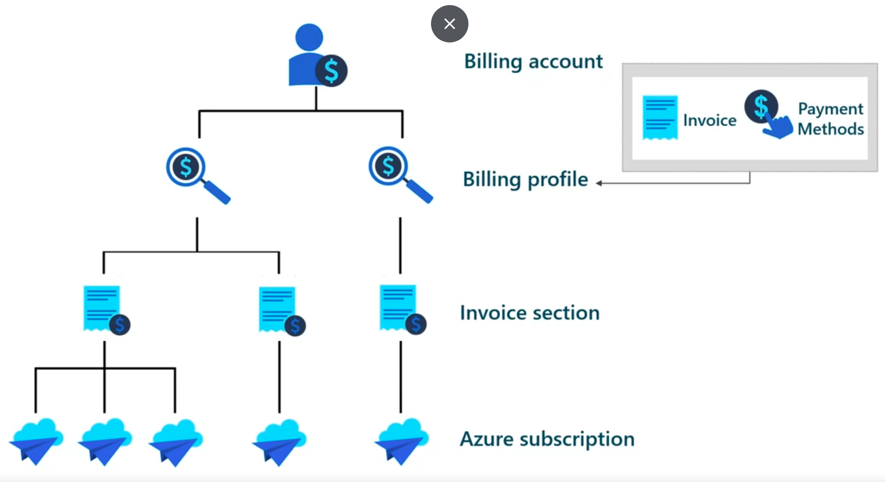

Azure management groups provide a level of scope above subscriptions. You organize subscriptions into containers called management groups and apply your governance conditions to the management groups. All subscriptions within a management group, automatically inherit the conditions applied to the management group. Management group gives you enterprise grade management at a large scale, no matter what type of subscriptions you might have. All subscriptions within a single management group must trust the same Azure AD tenant.

You can create a hierarchy that applies a policy. ie, you could limit VM locations to the US West region in a group called Production. This policy will inherit onto all the enterprise agreement subscriptions that are descendants of that management group and will apply to all VMs under those subscriptions. The security policy can’t be altered by the resource or subscription owner, which allows for improved governance.

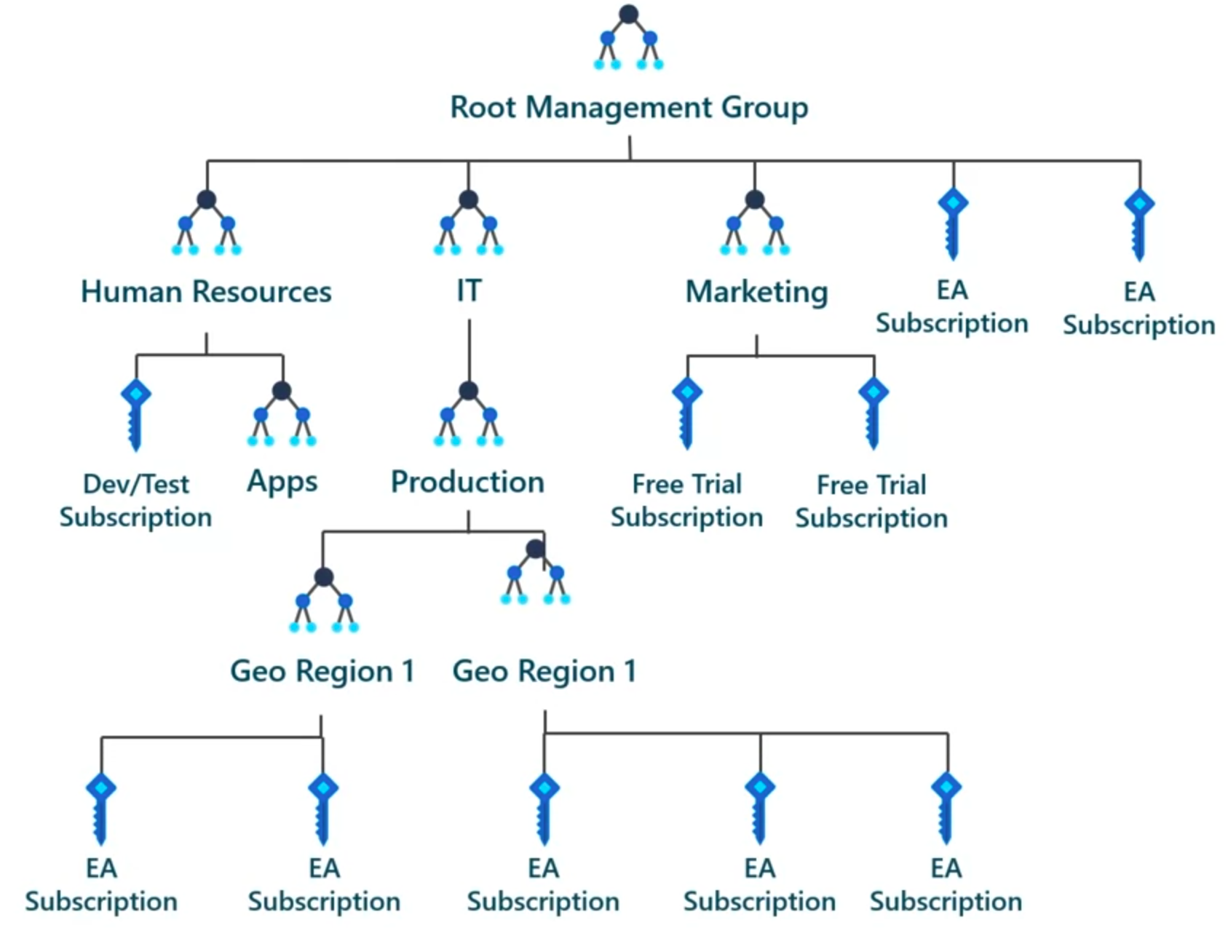

Another scenario where you would use management groups is to provide user access to multiple subscriptions. By moving multiple subscriptions under that management group, you can create on Role-Based access control RBAC assignment on the management group, which will inherit that access to all the subscriptions. One assignment on the management group can enable users to have access to everything they need, instead of scripting RBAC over different subscriptions.

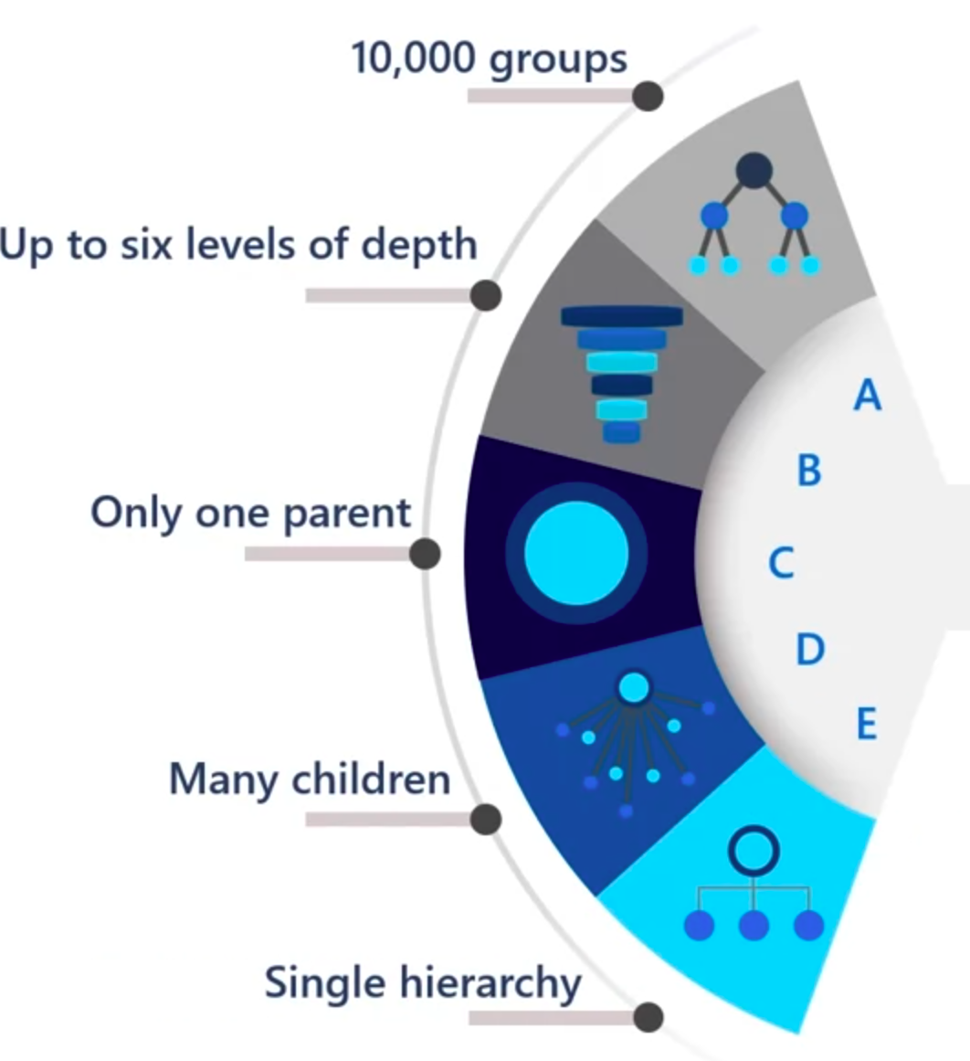

* Up to 10k management groups can be supported in a single directory.
* A management group tree can support up to six levels of depth. This limit doesn’t include the root level or at the subscription level.
* Each management group and subscription can support only one parent.
* Each management group can have many children.
* And all subcriptions and managements groups are within a single in each directory.

AFTER Created a subscriptions ready to start creating resources on storing them in resource groups.

* **Resources**, a manageable item that’s available through Azure.VM or storage accounts, web apps, databases and Virtual Networks are example of resources.
* **Resource group**, a container that holds related resources for an Azure solution. Resource group include resources that you want to manage as a group. Resource groups are a fundamental element off the Azure platform. Our resource group is a logical container for resources deployed on Azure. These resources are anything you create in an Azure subscription like VM, Azure application gateway instances and Azure cosmos DB instances. All resources must be in a resources group , and a resource can only be a member of a single resource group. Many resources can be moved between resource groups, with some services having specific limitations or requirements to move. Resource group can’t be nested before any resource could be provisioned, you need a resource group for it to be placed in.

Resource groups exist to help manage and organize your Azure resources, by placing resources of similar usage type or location in a resource group, you can provide order and organization to resource you can create in Azure.

Logical grouping is the aspect that you are most interested in here because resources can be become disordered.

* If you deleted a resource group, all resources contained within it are also deleted. Organizing resources by life cycle could be useful in non-production environments, where you might try an experiment and then dispose of it. Resource groups make it easy to remove a set of resources all at once.
* Can also apply permissions to ease administration on limit access. Resource group are also a scope for applying role based access control permissions.
* ARM, Azure Resource Manager, is the deployment and management service for Azure. It provide a management layer that enables you to create, update and delete resource in your Azure account. You use management features like access control, locks and tags to secure and organize your resources after deployment. ARM authenticates and authorizes the request. ARM sends the request to the Azure service which takes the requested action because all requests are handled through the same API .

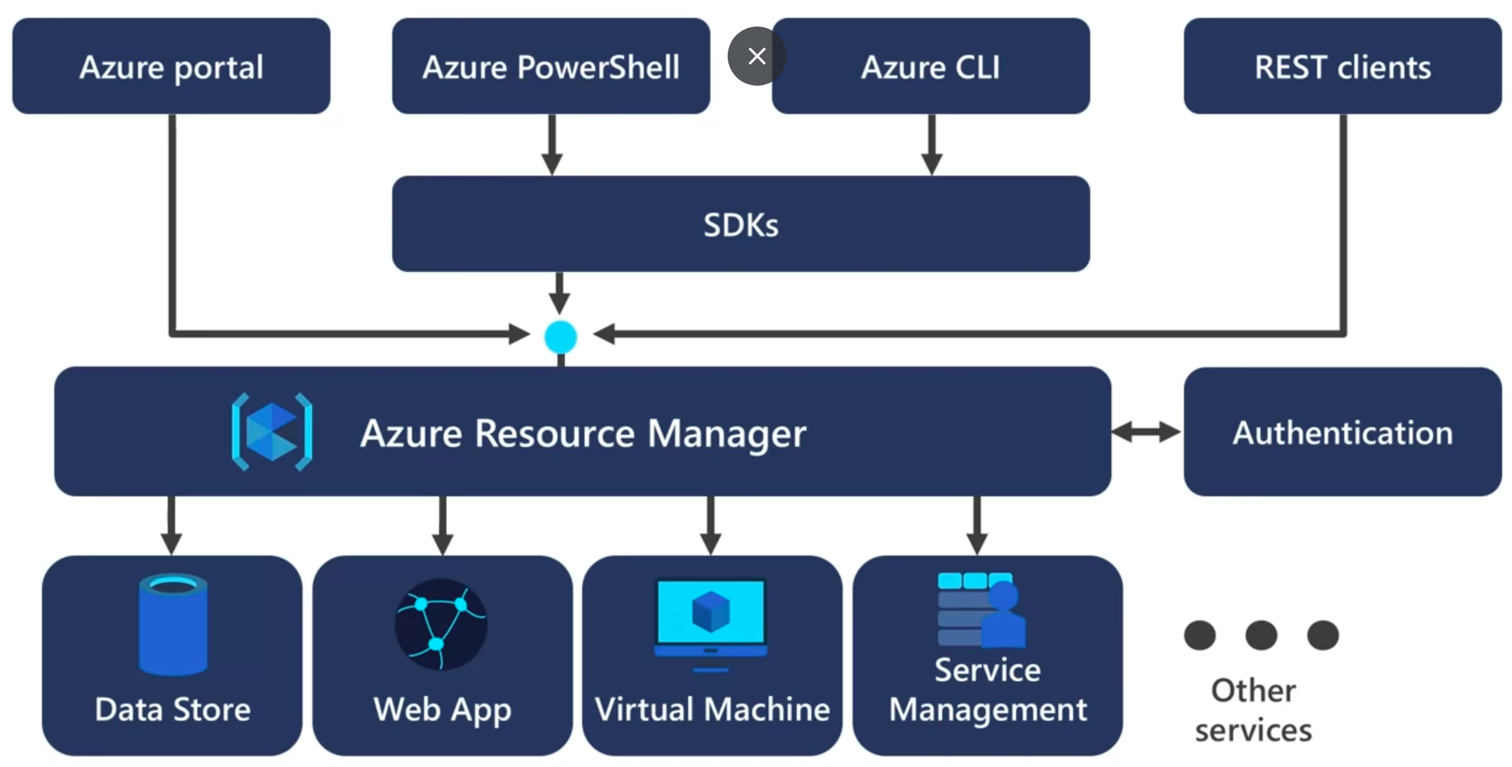

All capabilities that are available in the azure portal are also available through PowerShell, the azure CLI, Rest API and Client SDK.

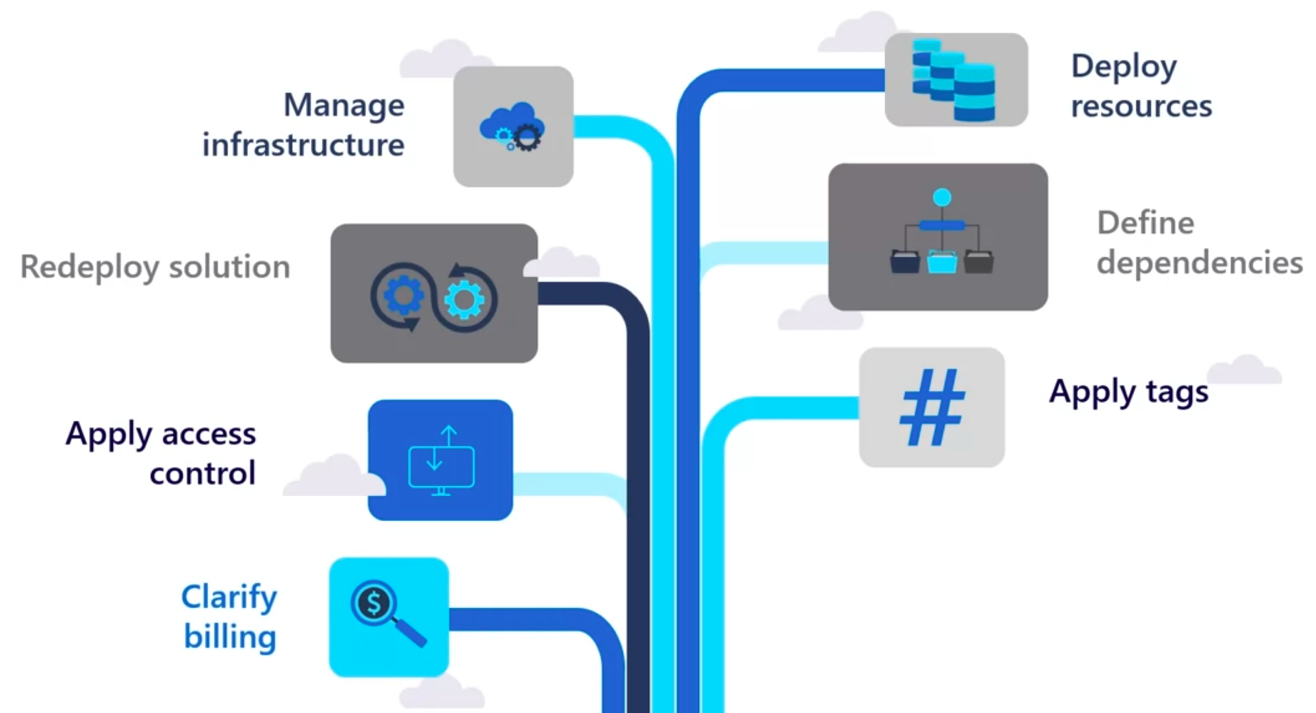

Resources are created in regions, which are different geographical locations around the globe that contain Azure data centers. Make sure your data and services are redundant.

* 1. **A region** is a geographical area that contains at least one but potentially multiple data centers that are nearby a network together with a low latency network. Regions provide better scalability and redundancy. A region so the workload are appropriately balanced. Some services or VM features are only available in certain regions, such as specific VM sizes or Storage types. Regions gives you the flexibility to bring applications closers to your users no matter where they are. Regions provide better scalability and redundancy.

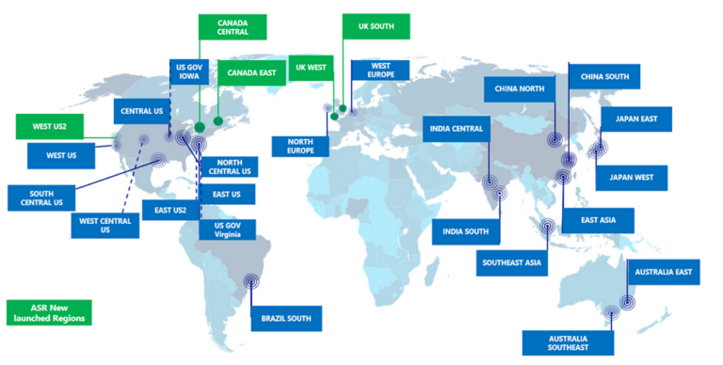 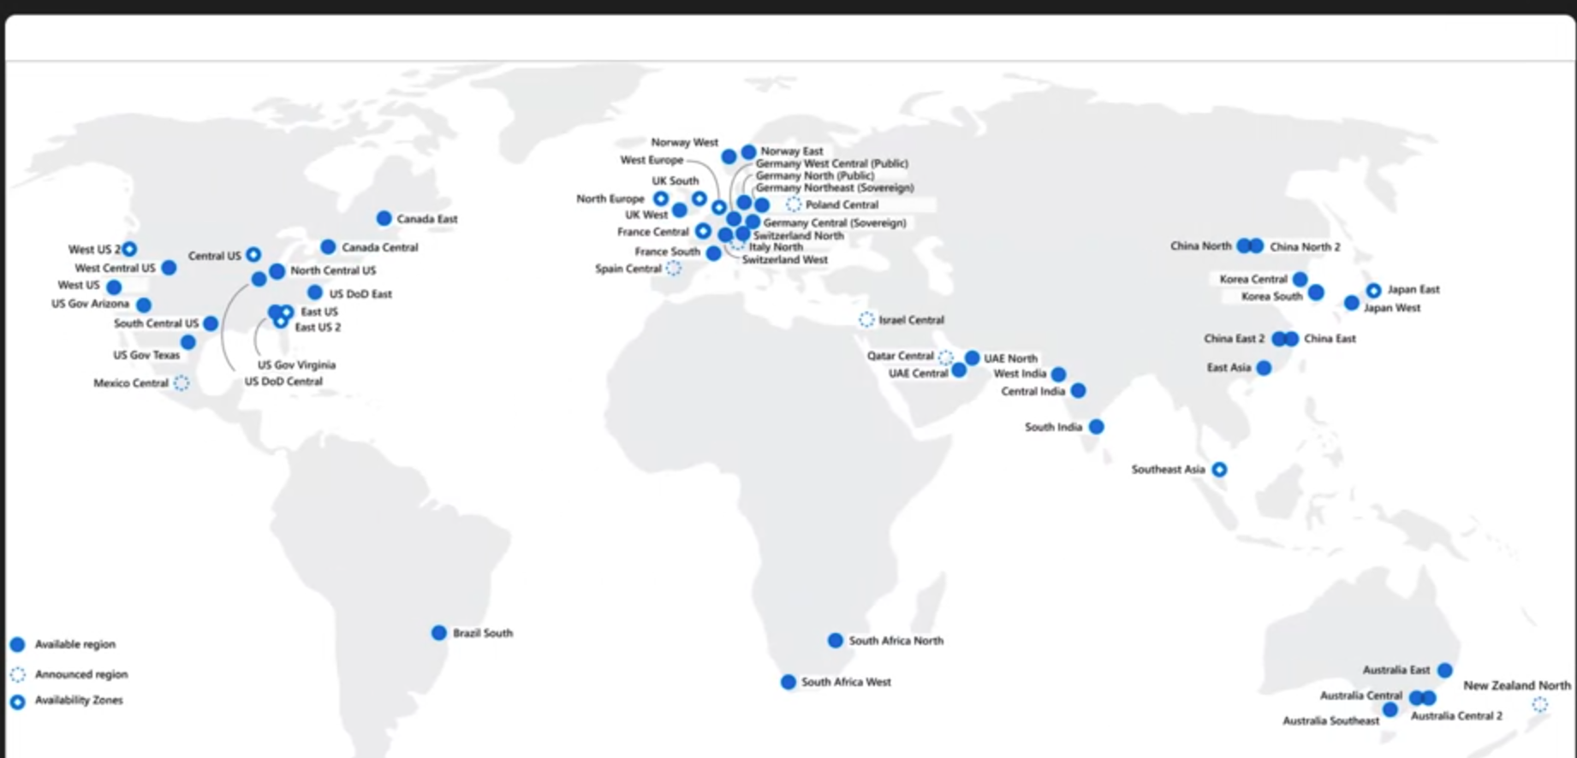

* 1. **Availability Zones**, physically separate data centers within an Azure region. Each availability zone is made up of one or more data centers equipped with independent power, cooling and networking. An availability zone is set up to be an isolation boundary. If one zone goes down, the other continues working. Availability Zones are connected through high speed private fiber optic networks.

**Not every region has support for Availability zones.**

Availability Zones are primarily for VMs, managed disks, load balances and SQL databases.

Availability zones are created by using one or more data centers. There’s a minimum of three zone within a single region.

Azure services that support availability zones fall into :

1. **Zonal Services**,
2. **Zone-redundant services**, replicates automatically across zones.

Each Azure region is always paired with another region within the same geography, such us US, Europe, or ASIA at least 300 miles away. This approach allows for the replication of resources such as VM storage. If an extensive Azure outage occurs, one region out of every pair is prioritized to make sure at least one is restored as quickly as possible for applications hosted in that region pair.

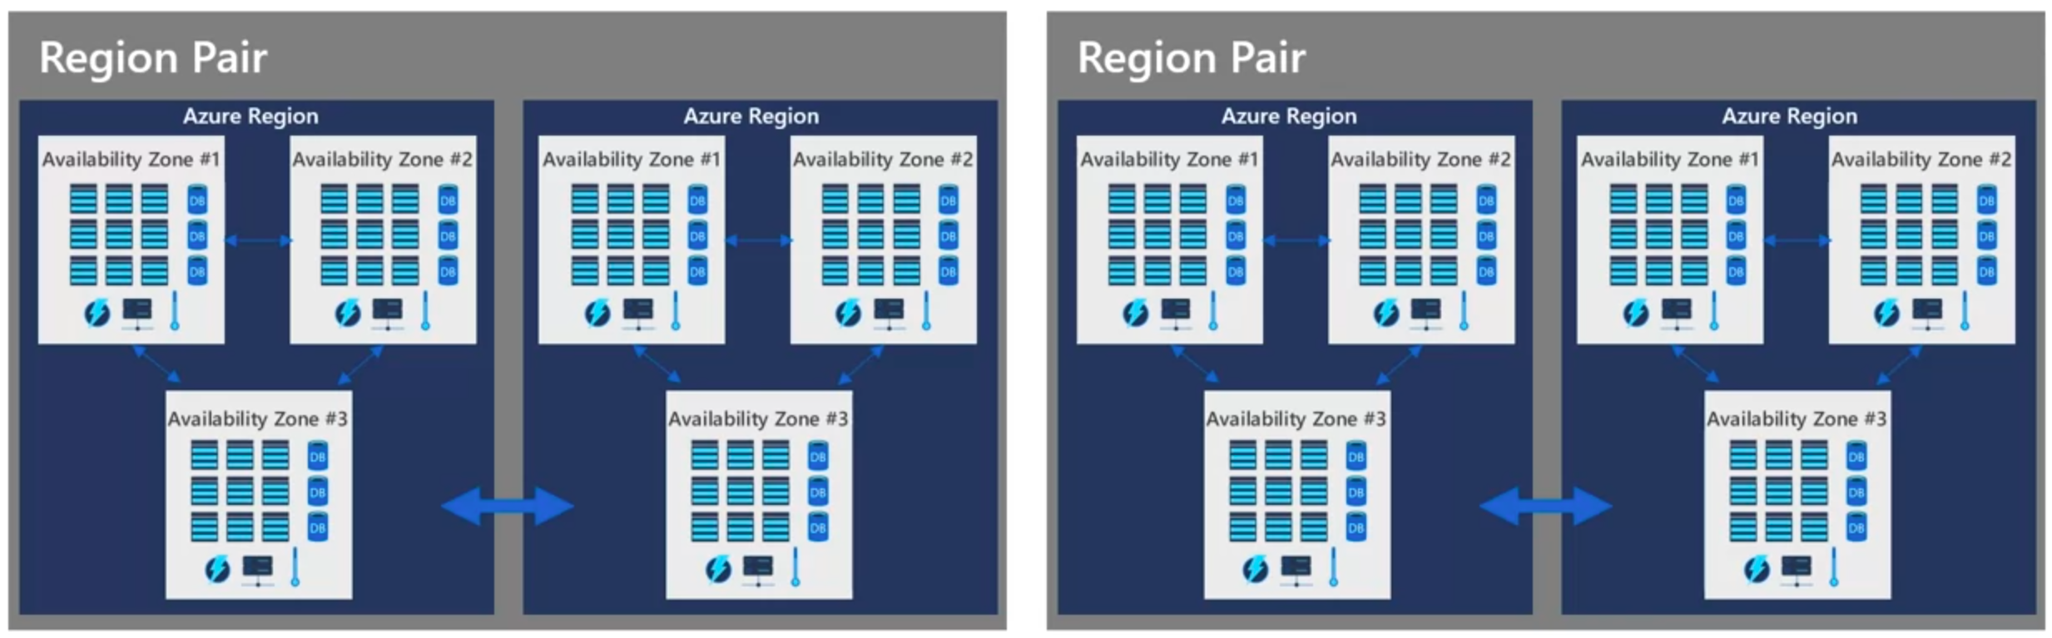

EXERCISES :

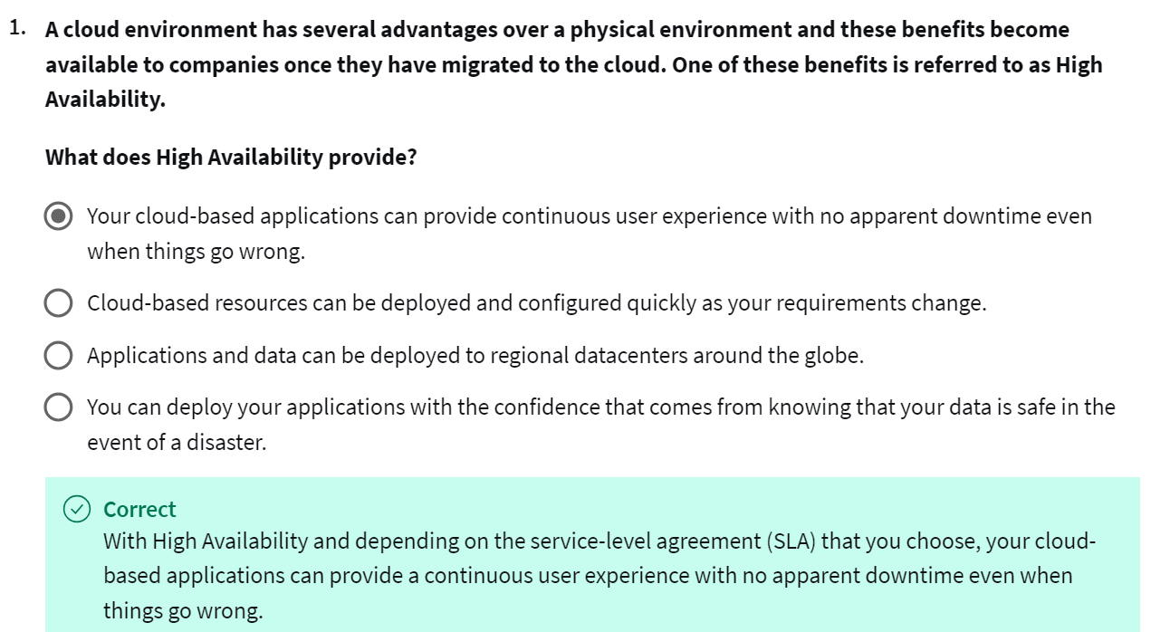 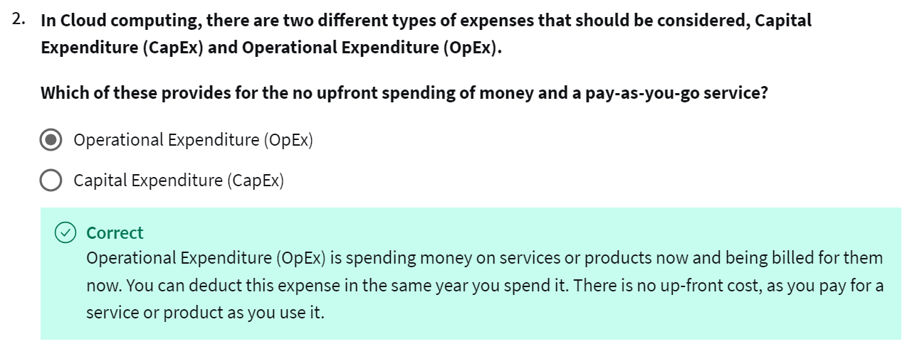

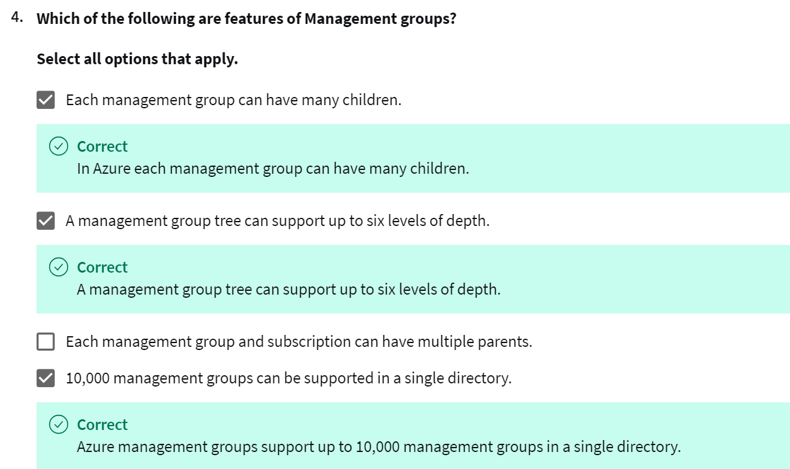

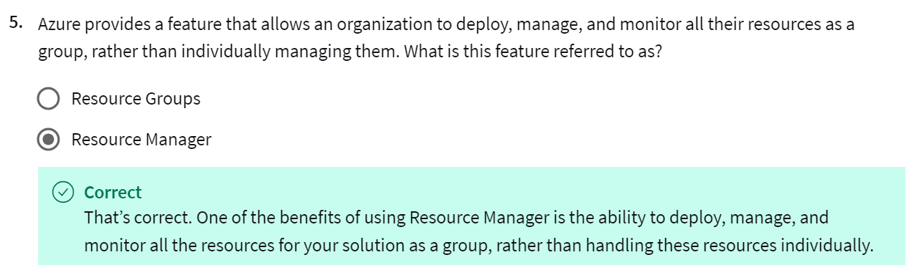 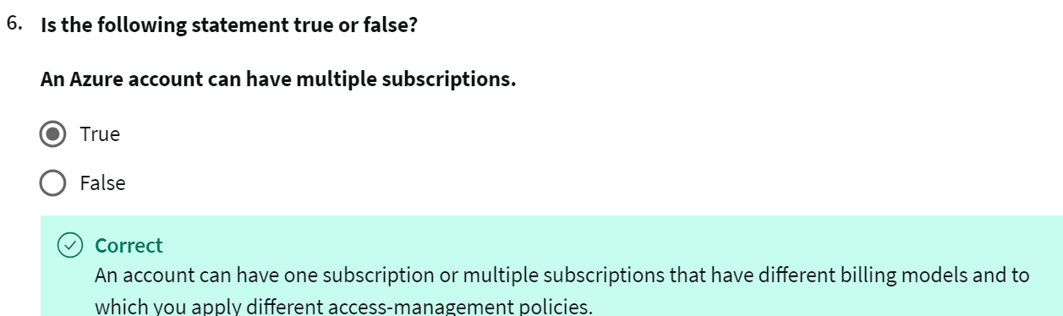

Reading :

* 1. <https://learn.microsoft.com/en-us/training/paths/describe-azure-management-governance/>
  2. <https://learn.microsoft.com/en-us/azure/reliability/availability-zones-overview?tabs=azure-cli>
  3. <https://learn.microsoft.com/en-us/azure/governance/management-groups/overview>
  4. https://learn.microsoft.com/en-us/azure/azure-resource-manager/templates/